1. Overview and Motivation: Field goal percentage is one of the most important NBA metrics to analyze players’ strength, and a shot chart is the most effective to visualize a player’s efficiency and field goal percentage for all the spots on the court. This project intends to provide a straightforward visualization that demonstrates each NBA player’s frequency and efficient of shots on the court.
2. Related Work: The project is inspired by the NBA assignment of the class, where we got to visualize each player’s salary and key metrics like points, assists, rebounds, blocks, steals, two-point field goals and three-point field goals. The project is a good complement to this pre-existing visualization, and is able to shed more light on two-point and three-point field goals.
3. Questions: For each player, which spot is his “sweet spot”? More specifically, where does this player intend to attempt shots more frequently? Where is this player most efficient at? On each spot, who is the most efficient player? How does that compare to the team’s data? What is the role of a player in his team?
4. Data: Source is stats.nba.com. There is a library where I can directly get data from this API. Basically, for each player, first get his player id and then I get the shots data for this id for the current season. This returns a JavaScript Promise, where one key is “shot_Chart_Detail”. I use a call back function to process it, and put every spot’s data into an array, and this is our source of data.
5. Implementation: This is the shot chart for LeBron James. For each graphical mark, larger size represents more shots there and vice versa. Reddish hue means higher field goal percentage at that spot and blueish means lower.

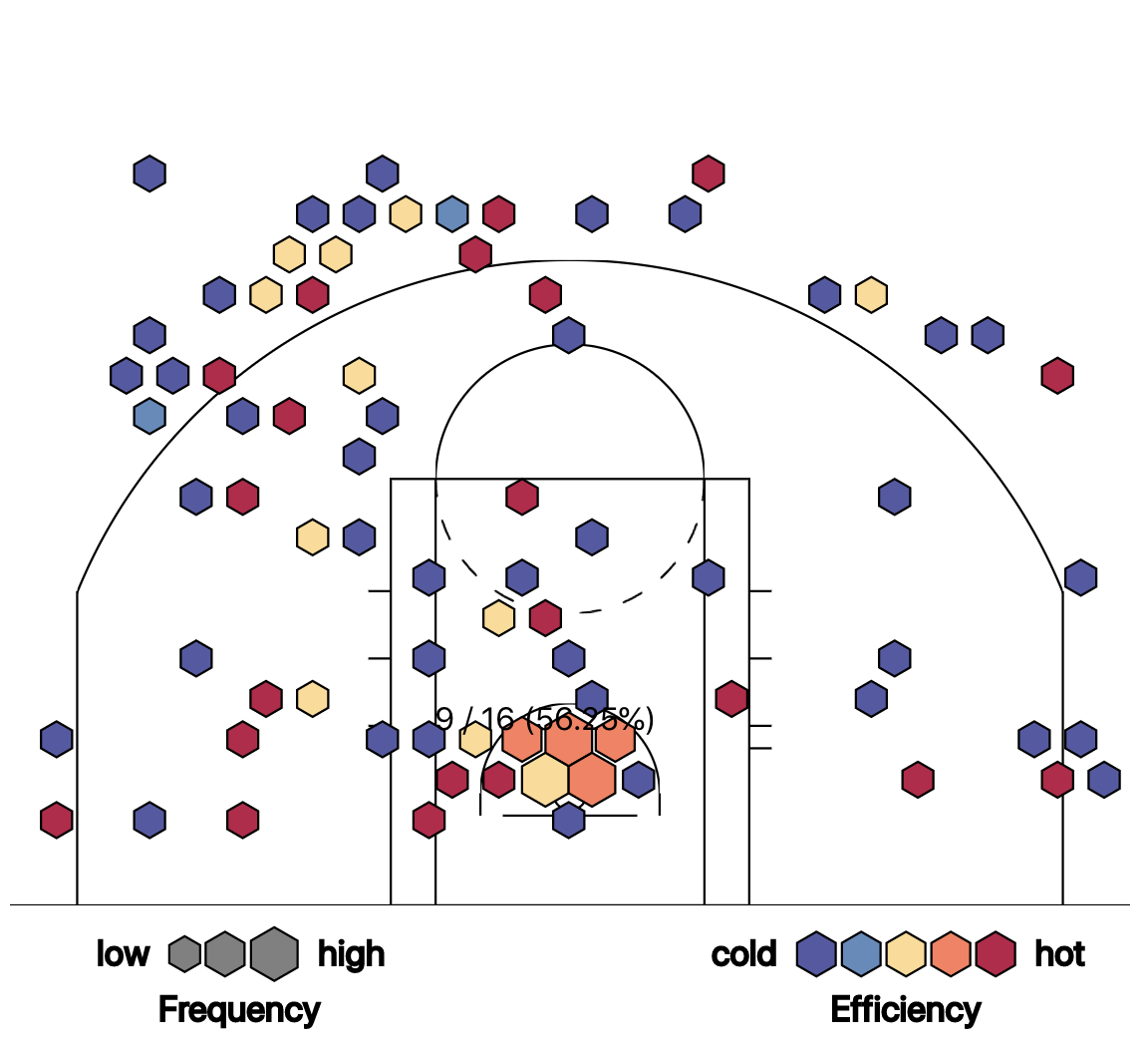

1. Exploratory Data Analysis

I initially use circle graphical marks to look at it. There are a lot of overlapping so it is hard to read, so I decided to use hexagons.

1. Design Evolution

I considered using circle graphical marks and using only two colors. For circle graphical marks, there are overlapping so it hard to read; it is not pre-attentive. And using two colors (green and red) also makes it hard to let the user detect which color represents higher efficiency; it is not pre-attentive as well. The two colors only differ in hue and have same luminance so that is the reason why it is pre-attentive. As discussed in class, RGB color space is okay only if we want to choose a single color for display in isolation and does not fit all other cases. Therefore, eventually, I chose hexagons with gradually changing color. Also, it has evolved from a single shot chart of a player whose name has to be hardcoded in the backend to a player shot chart along with his team’s shot chart with a player search bar. These design decisions do not deviate from my original proposal.

1. Analysis

I could easily see where a player tends to take more shots or is more efficient through the visualization as well as a player’s role in a team, and this answered my questions. For future improvement, I have a better linking between the player’s data and the team’s data so that the it is easy to compare and detect trends.